View this in web layout mode to get the alignment right!!

*Going to the movies is better than staying home and watching TV.*

1. No distractions or interruptions
2. No advertisements
3. No distractions from friends and family
4. No temptation to multitask
5. The audio visual experience is better
6. The screen is larger
7. The dialogue and sound track are engineered for maximum viewing pleasure
8. Reason
9. More active
10. Going to the movies involves getting out of the house
11. Watching TV is the most passive thing a person can do
12. Reason

**Going to the movies is better than watching TV at home.**

**No chores or housework**

**No work emails**

**No chores or housework**

**No unexpected friends or family**

**No work emails**

**No distractions or interruptions**

**No unexpected friends or family**

**Larger screen**

**Better sound**

**No distractions or interruptions**

**The audio visual experience is better.**

**Engineered to feel immersive**

**Going to the movies is better than watching TV at home.**

**The audio visual experience is better.**

**No distractions or interruptions**

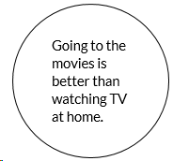

**Gets you around other people**

**Gets you out of the house**

**TV is really passive**

**More active**

**More active**

**Going to the movies is better than watching TV at home.**

**The audio visual experience is better.**

**Going to the movies is better than watching TV at home.**

**No distractions or interruptions**

**The audio visual experience is better.**

**More active**



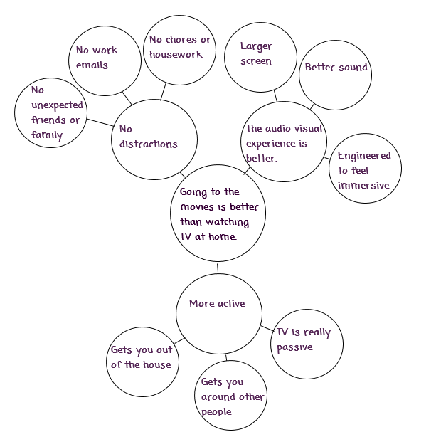 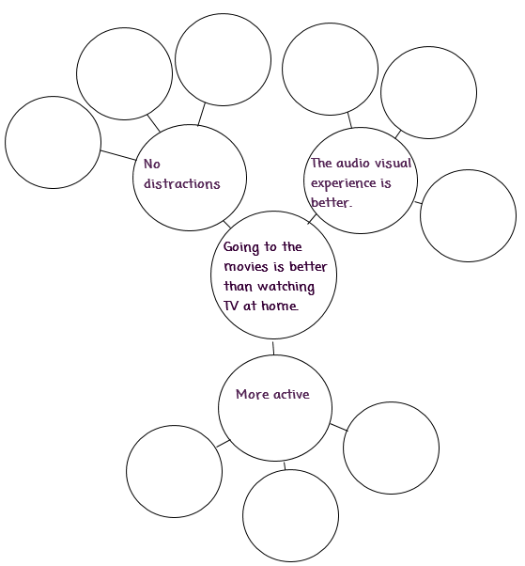

**No distractions or interruptions**

**Going to the movies is better than watching TV at home.**

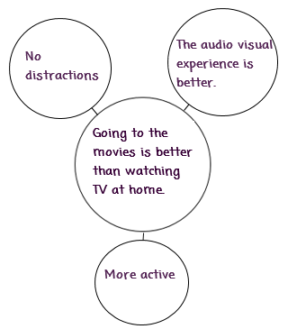 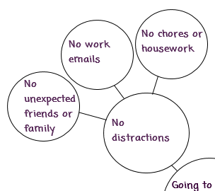



**Your topic**